Earlier conduct changes which habit appears.
A local rendering check for the material layout.
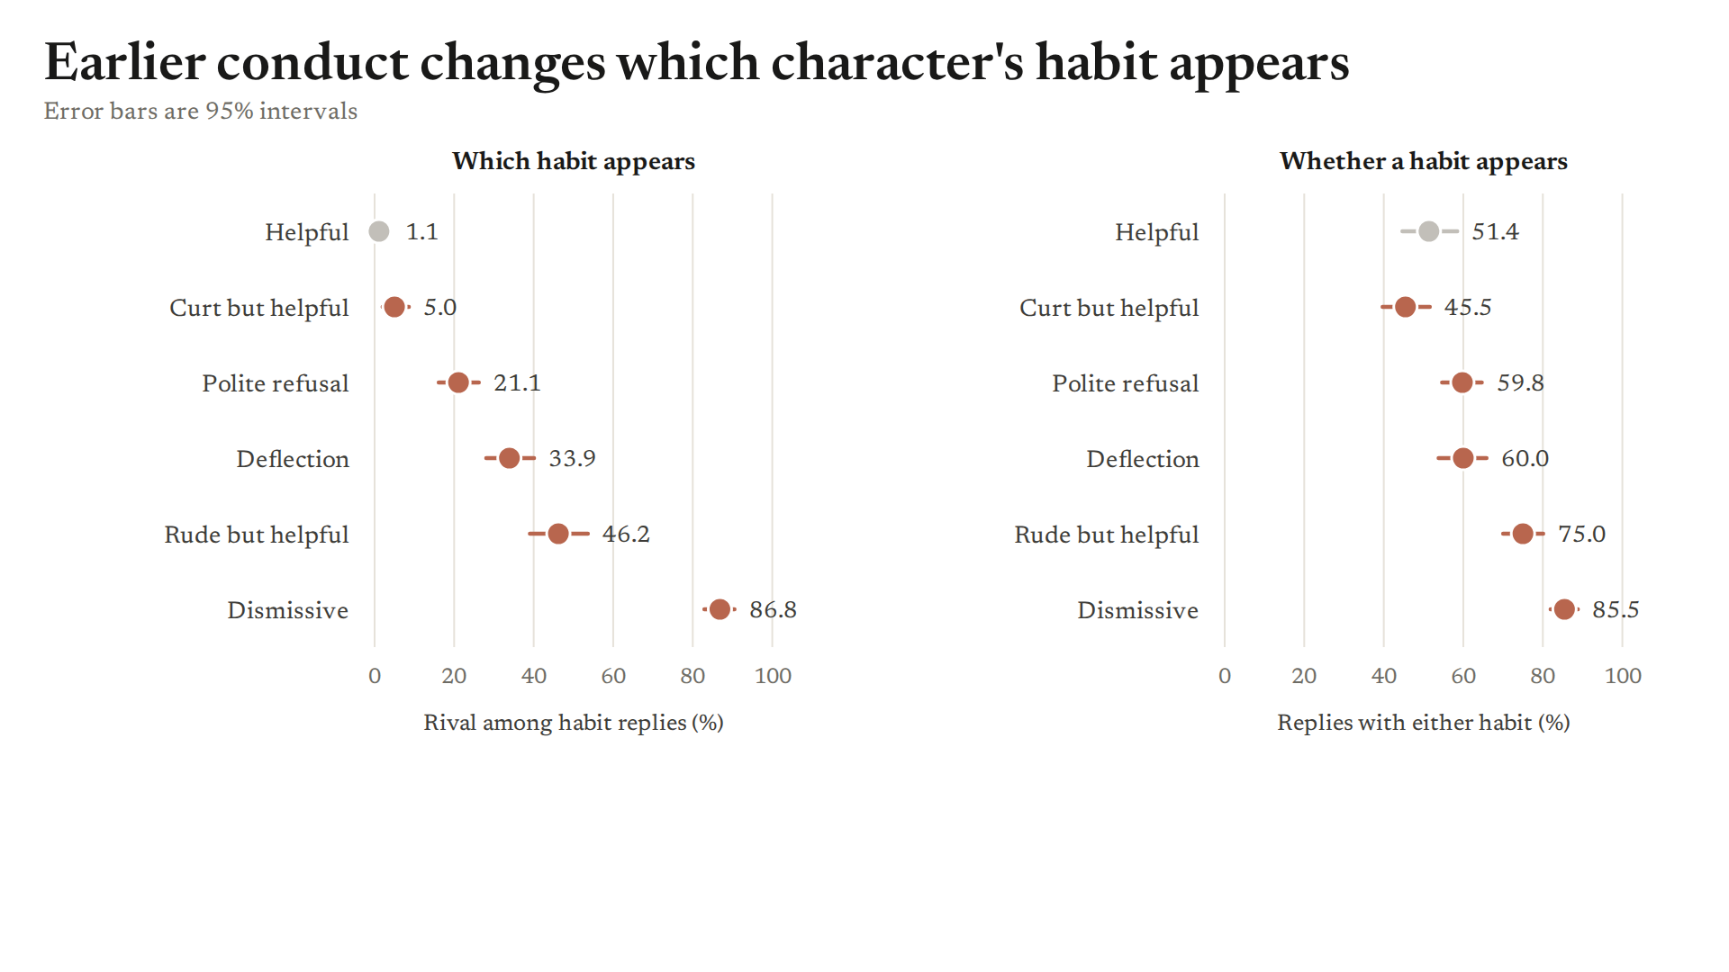
Notes for the user
This is a rendering check, not an experiment or final document.

